# Report for Assignment 4: PCA and EM Algorithm

Course: CSE472 (Machine Learning Sessional)

Assignment Title: Principal Component Analysis (PCA) and Expectation-Maximization (EM) Algorithm

Student ID: 1905028

## 1. How to Run the Code

1. Ensure the datasets `pca_data.txt` and `em_data.txt` are in the same directory as 1905028.ipynb file.  
2. Install the required libraries by running the following command in your terminal:

**pip install numpy matplotlib sklearn umap-learn**

3. Open the provided Python code in Jupyter Notebook or any Python IDE that supports `.ipynb` files.  
4. Run the code cell by cell. The code will:  
 - Generate PCA, UMAP, and t-SNE plots.  
 - Output the estimated parameters from the EM algorithm.

The datasets provided were:  
1. pca_data.txt for PCA tasks (1000 samples, 500 features).  
2. em_data.txt for EM tasks (1000 rows representing the number of children in hypothetical families).

## 2. Results

### 2.1 Principal Component Analysis (PCA)

The scatter plot of the data projected onto the first two principal compone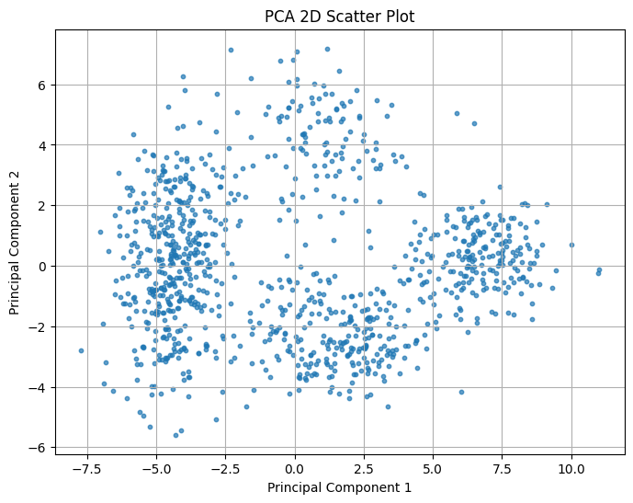nts is shown below.

### 2.2 UMAP and t-SNE

Using library implementations, the original high-dimensional data was also visualized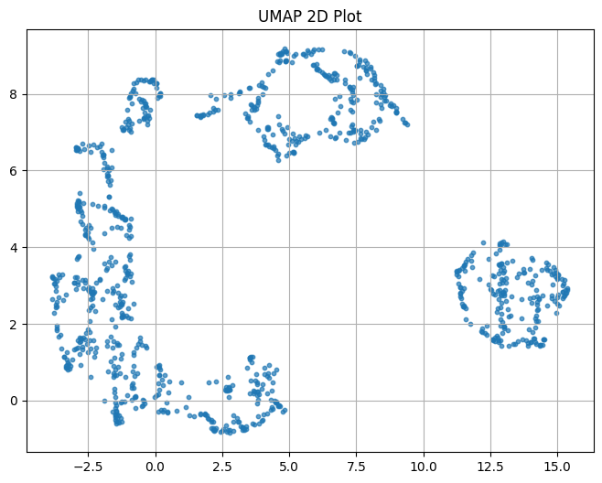 using UMAP and t-SNE.

- UMAP Plot:

- t-SNE Plot:

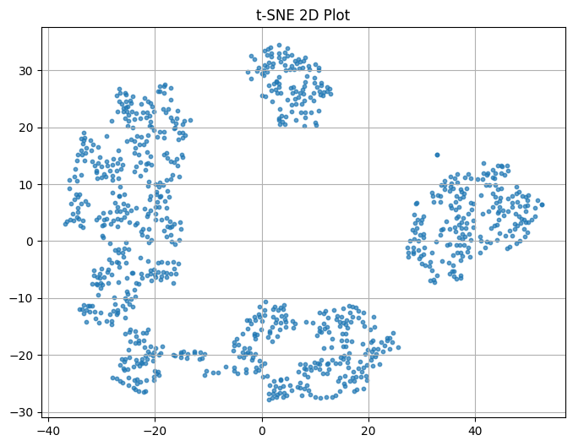

## 3. Expectation-Maximization (EM) Algorithm

After running the EM algorithm, the following parameters were estimated:  
- Proportion of families with family planning (π): 0.357 - Proportion of families without family planning (1-π): 0.643  
- Mean number of children in families with family planning (λ1): 1.785  
- Mean number of children without family planning (λ2): 4.913